**ST. XAVIER’S COLLEGE**

**MAITIGHAR, KATHMANDU**



**COMPUTER GRAPHICS**

**LAB ASSIGNMENT #6**

**Submitted by:**

NARAYAN PANTHI

013BSCCSIT024

**Submitted to:**

Er. Anil Sah

Department of Computer Science

St. Xavier’s College

Maitighar, Kathmandu

# STATEMENT: IMPLEMENT MIDPOINT ELLIPSE ALGORITHM.

# Algorithm:

|  |
| --- |
| Step 1: input center (xc,yc) and rx and ry for the ellipse and obtain the first point as (x0,y0)=(0, ry)  Step 2: calculate initial decision parameter value in region 1 as  P10=  Step 3: at each xk­ position, in region1, starting at k=0, compute  xk+1=xk+1  if p1k=p1k+2xk+1+  yk+1=yk+1  otherwise next point to plot is  yk+1=yk-1  P1k+1=P1k+xk+1+-2yk+1 with xk+1=xk+1 and yk+1=yk-1  Step 4: calculate the initial value of decision parameter at region 2 using last calculated point say (x0,y0) in region 1 as  P20=  Step 5: at each yk position in region 2 starting at k=0, perform computation  yk+1=y-1  if P2k>0, then  xk+1=xk  P2k+1=P2k-  Otherwise  xk+1=xk+1  P2k+1=P2k+2 where xk+1=xk+1 and yk+1=yk+1  Step 6: determine the symmetry points in other three quadrants.  Step 7: move each calculated point (xk,yk) on to the centered (xc,yc) ellipse path as  xk=xk+xc  yk=yk+yc  Step 8: repeat the process for region 1 until and region 2 until (xk,yk)=(rx,0). |

# Source code:

|  |
| --- |
| //---------------------------------------------------------------------------  #include <vcl\vcl.h>  #pragma hdrstop  #include "Unit1.h"  //---------------------------------------------------------------------------  #pragma resource "*.dfm"  TForm1 *Form1;  int xc,yc,rx,ry,x0,y0,pk;  //---------------------------------------------------------------------------  __fastcall TForm1::TForm1(TComponent* Owner)  : TForm(Owner)  {  }  //---------------------------------------------------------------------------  void __fastcall TForm1::Button1Click(TObject *Sender)  {  xc=StrToInt(Edit1->Text);  yc=StrToInt(Edit2->Text);  rx=StrToInt(Edit3->Text);  ry=StrToInt(Edit4->Text);  x0=0;  y0=ry;  pk=(ry*ry)-(rx*rx*ry)+((rx*rx)/4);  while((2*x0*ry*ry)<(2*y0*rx*rx))  {  Image1->Canvas->Pixels[xc+x0][yc-y0]=RGB(10,55,250);  Image1->Canvas->Pixels[xc-x0][yc+y0]=RGB(255,0,0);  Image1->Canvas->Pixels[xc+x0][yc+y0]=RGB(0,255,0);  Image1->Canvas->Pixels[xc-x0][yc-y0]=RGB(0,0,255);  if(pk<0)  {  x0=x0+1;  pk=pk+(2*ry*ry*x0)+(ry*ry);  }  else  {  x0=x0+1;  y0=y0-1;  pk=pk+(2*ry*ry*x0+ry*ry)-(2*rx*rx*y0);  }  }  pk=((float)x0+0.5)*((float)x0+0.5)*ry*ry+(y0-1)*(y0-1)*rx*rx-rx*rx*ry*ry;  while(y0>=0)  {  Image1->Canvas->Pixels[xc+x0][yc-y0]=RGB(10,55,250);  Image1->Canvas->Pixels[xc-x0][yc+y0]=RGB(255,0,0);  Image1->Canvas->Pixels[xc+x0][yc+y0]=RGB(0,255,0);  Image1->Canvas->Pixels[xc-x0][yc-y0]=RGB(0,0,255);  if(pk>0)  {  y0=y0-1;  pk=pk-(2*rx*rx*y0)+(rx*rx);  }  else  {  y0=y0-1;  x0=x0+1;  pk=pk+(2*ry*ry*x0)-(2*rx*rx*y0)-(rx*rx);  }  }  }  //--------------------------------------------------------------- |

# Output:

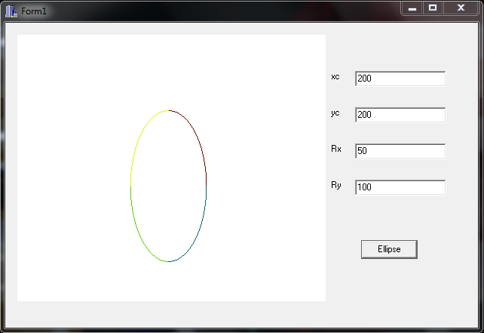

# Conclusion:

Therefore, the midpoint ellipse algorithm was implemented as shown.